Experiment 13: Perspective Transformation on a Video
Software / Tools: Python · OpenCV (cv2) · NumPy

AIM
To apply a Perspective Transformation to every frame of a video in real time.
ALGORITHM
1. Import OpenCV and NumPy.
2. Open the video using cv2.VideoCapture().
3. Read the first frame to get the frame dimensions.
4. Define source and destination points and compute the perspective matrix once.
5. Loop through each frame: read the frame, apply cv2.warpPerspective() using the matrix.
6. Display the warped frame; break on 'q' key.
7. Release the capture and close windows.
PROGRAM (SOURCE CODE)
import cv2
import numpy as np

cap = cv2.VideoCapture("input_video.mp4")
ret, frame = cap.read()
(h, w) = frame.shape[:2]

pts1 = np.float32([[0, 0], [w, 0], [0, h], [w, h]])
pts2 = np.float32([[50, 50], [w-100, 30], [50, h-30], [w-50, h-100]])
M = cv2.getPerspectiveTransform(pts1, pts2)

while cap.isOpened():
ret, frame = cap.read()
if not ret:
break
warped = cv2.warpPerspective(frame, M, (w, h))
cv2.imshow("Perspective Transformed Video", warped)
if cv2.waitKey(25) & 0xFF == ord('q'):
break

cap.release()
cv2.destroyAllWindows()

OUTPUT
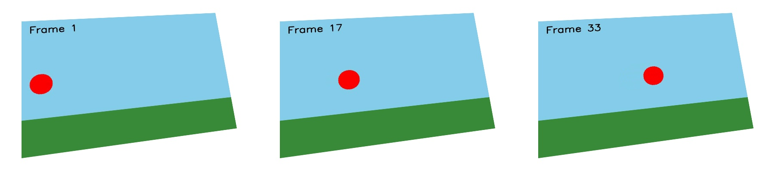
Fig. 13 — Output of Experiment 13: Perspective Transformation on a Video.
RESULT
Apply a Perspective Transformation to every frame of a video in real time — completed successfully, as demonstrated in the output shown above.

